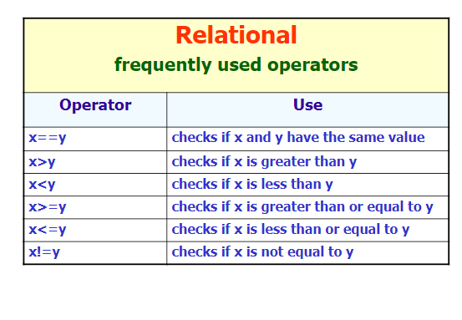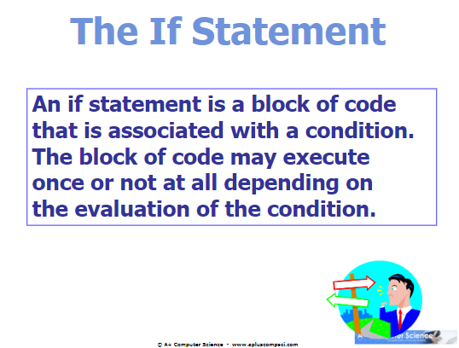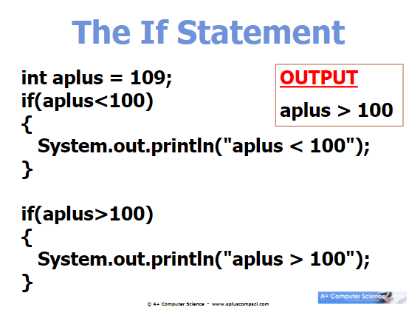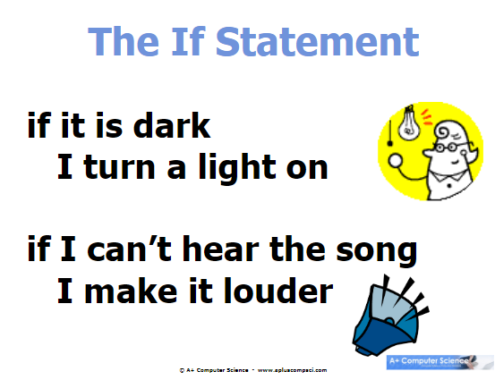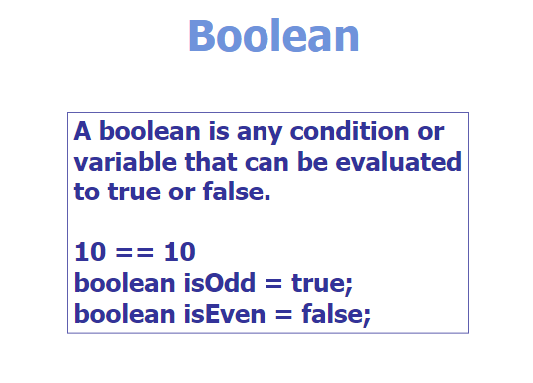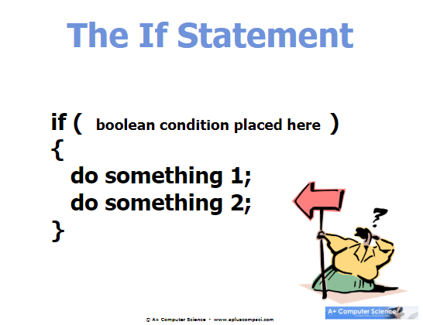

**when looking at **Strings**...use **“this.equals(“x”);”** to compare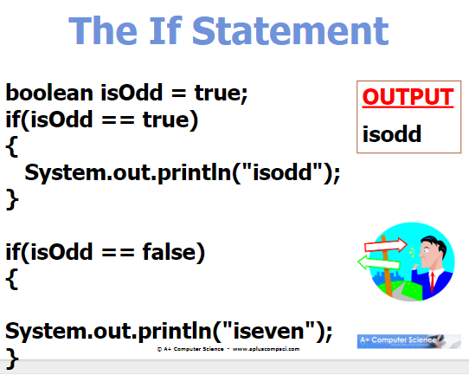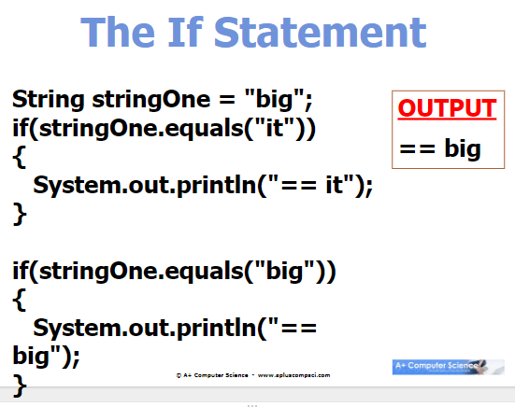

**if a boolean is TRUE, then the code will run no matter if you say “== true”; although, it won’t work with false (can use ! to make it true)

**If you have an if statement that’s supposed to print only ONE statement, you can have a free line without curly braces. EXAMPLE BELOW:

//no need for curly braces when executing only ONE statement (more than one and you need a pair of curly braces

if (condition = true)

statement;